**Database for a soccer retail store**

Group Members: Thomas McMahon

Introduction:

This database system was developed for a soccer retail store so that they could track customers, employees, products and sales. It is modeled after a soccer store that was in Ramsey, a family owned store that did not have many employees or the need to delineate between ranks of the employees there. This database would give them the necessary tools to keep track of who works there, and both the customers and employees who took part in each sale.

The functions that were developed would allow the company to add employees easily and also customers to their database in case they wanted to send mass emails out with offers and sales. It also has a built in trigger for each one of those functions that would allow for the employee updating the database to know that the data was entered successfully. Since the users are assumed to be naive, since it is a small family owned store, it will be laid out for them. In addition to that, there is functionality so that they could input a discounted price at the time of sale or prior for whatever reason necessary. This would allow them to have the necessary tools to track sales, and if they wanted to keep a reward-type system in the future as the total amount of money spent by a customer on an account could be accessed through the data stored.

ER Diagram:

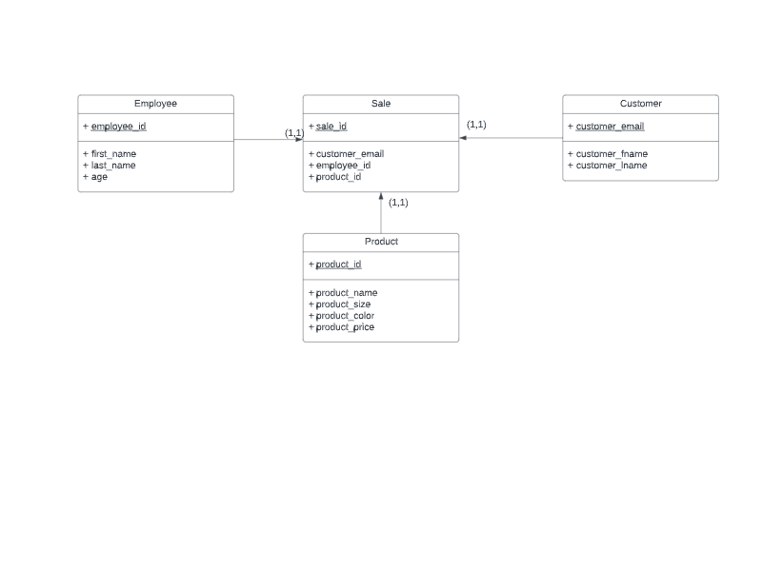

DATA DICTIONARY:

Sample of the data scheme for employee

| Attribute name | Data Type | Size | Allowed NULL |
| --- | --- | --- | --- |
| employee_id | NUMBER | 20 | No (PK) |
| first_name | VARCHAR | 20 | No |
| last_name | VARCHAR | 30 | No |
| age | NUMBER | 3 | No |

Sample of the data scheme for customer

| Attribute name | Data Type | Size | Allowed NULL |
| --- | --- | --- | --- |
| customer_email | VARCHAR | 50 | No (PK) |
| customer_fname | VARCHAR | 20 | Yes |
| customer_lname | VARCHAR | 20 | Yes |

Sample of the data scheme for product

| Attribute name | Data Type | Size | Allowed NULL |
| --- | --- | --- | --- |
| product_id | NUMBER | 20 | No (PK) |
| product_name | VARCHAR | 20 | No |
| product_color | VARCHAR | 20 | No |
| product_size | VARCHAR | 20 | No |
| product_price | NUMBER | 10 | No |

Sample of the data scheme for sale

| Attribute name | Data Type | Size | Allowed NULL |
| --- | --- | --- | --- |
| sale_id | NUMBER | 10 | No (PK) |
| customer_email | VARCHAR | 50 | No (FK to customer) |
| employee_id | NUMBER | 20 | No (FK to employee) |
| product_id | NUMBER | 20 | No (FK to product) |